# Google API with Polymer

## Steps to create OAuth2 client in google

1. Open the [Google API Console Credentials page](https://console.developers.google.com/apis/credentials).
2. From the project drop-down, choose **Create a new project**, enter a name for the project, and optionally, edit the provided Project ID. Click **Create**.
3. On the Credentials page, select **Create credentials**, then select **OAuth client ID**.
4. You may be prompted to set a product name on the Consent screen; if so, click **Configure consent screen**, supply the requested information, and click **Save** to return to the Credentials screen.
5. Select **Web Application** for the **Application Type**. Follow the instructions to enter JavaScript origins, redirect URIs, or both.
6. Click **Create**.
7. On the page that appears, copy the **client ID** and **client secret** to your clipboard, as you will need them when you configure your client library.

**Reference link:**

<https://developers.google.com/adwords/api/docs/guides/authentication>

Supporting packages are available for google api

<https://github.com/Scarygami/google-signin-samples>

<https://plus.google.com/+GerwinSturm/posts/TWDx14Gtqvi>

## Code to work with google api’s:

Step 1:

Install below mentioned bower components and add links in html page

<link rel="import" href="../bower_components/polymer/polymer.html">

<link rel="import" href="../bower_components/iron-localstorage/iron-localstorage.html">

<link rel="import" href="../bower_components/google-signin/google-signin.html">

<link rel="import" href="../bower_components/google-signin/google-signin-aware.html">

Step 2:

Add styles under template for google logo’s

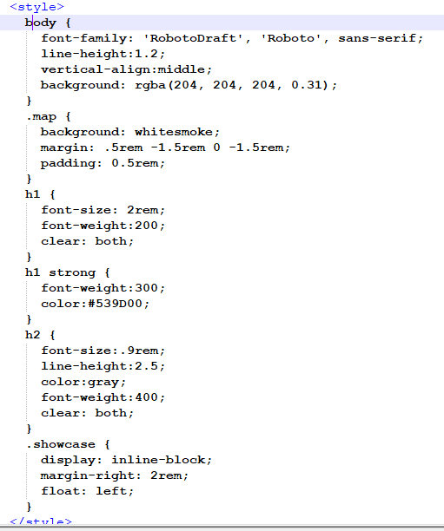

Step 3:

Add google or gogle plus tags under body

<google-signin brand="google" client-id="588627757546-g157nr15itj2ol5pmn1qb3a0qrqdeaan.apps.googleusercontent.com"></google-signin>

<google-signin brand="google-plus" client-id="588627757546-g157nr15itj2ol5pmn1qb3a0qrqdeaan.apps.googleusercontent.com"></google-signin>

Step 4:

Google sign in awre is require to listen login and logout from google.

<google-signin-aware

scopes="{{scope}}"

openid-prompt="{{openidPromptValue}}"

signed-in="{{signedIn}}"

offline="{{offline}}"

is-authorized="{{isAuthorized}}"

need-additional-auth="{{needAdditionalAuth}}"

on-google-signin-aware-error="handleSignInError"

on-google-signin-aware-success="handleSignIn"

on-google-signin-offline-success="handleOffline"

on-google-signin-aware-signed-out="handleSignOut"></google-signin-aware>

**Reference link for sample code**:

<https://github.com/poornachandrarao/PolymerWithGoogleApi>

**Issue with unwanted bower components:**

If there are any issues which are logically not meaningful and not able to find root cause then just follow below steps.

1. Delete bower_components and running bower cache clean,
2. Fix issue by installing individual packages bower install username/element-name rather than bower install element-name.

**Cookies Package:**

<https://github.com/andreasonny83/polymer-cookie/blob/master/polymer-cookie.html>